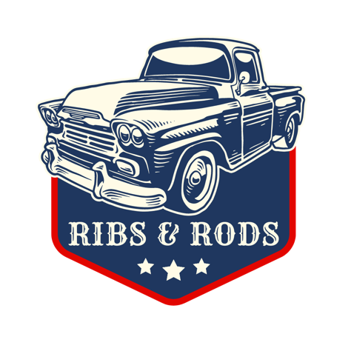 **Saturday April 6th, 2024**

**Location:** Main Street Clio, SC

**Entry Fee**: $150 per team (Made payable to the Town of Clio), Payment due at time of registration.

A paypal link can also be sent for payment online.

**Deadline**: Friday March 29th, 2024

An email will go out the week of the event with the final information your team will need.

**Cooking Instructions and Rules:**

* Team will be judged on Best Ribs, Best Chicken, Best Original Sauce
* Teams may prepare and cook Ribs and Chicken in any fashion they prefer so long as it is suitable to be served to the public.
* Teams must prepare Ribs and Chicken on site at Main Street Clio, South Carolina. The meat will be furnished and will be available for pickup **beginning at approximately 7:00am on April 6th, 2024**
* Each team will be responsible for cooking a minimum of 10 racks of Ribs
* Wood, gas, pellet, or charcoal grills are permitted.
* Each team must supply their own ingredients, grill, tools, and any other items needed.
* Teams are expected to serve their Ribs to the public from 4:30 p.m. until 5:15 p.m. and **only to guests with official event wristband**. Guests with bands may get 1 rib from your pit.
* Each team will be allotted a generous cooking space for truck, grill, and table. No two-story structures are allowed, and no on-site expansion beyond the allotted area will be allowed.
* Teams may NOT sell food or beverages to the public. Under NO circumstances are alcoholic beverages to be distributed to the public by the teams.
* All teams are requested to respect the rights of others with special emphasis against loud music, profane language, and infringement on adjoining sites. Teams must conduct themselves in a professional manner at all times.
* No pets allowed.
* **Teams must have gloves, prepare meat under cover, and have a hand washing station.**
* **No overnight camping prior to or after the contest on April 6th, 2024.**

**Judging and Awards**

Teams will random draw time slots to be their “Turn in Time”. Teams are expected to have their choice Ribs and Chicken prepared in their given boxes and present to judges at their assigned time. A 5 minute window following a teams assigned Turn in Time will be allowed. Any team missing their Turn in Time will not be judged. Turn in times will start at 4:00. Winners will be announced, and awards presented at 5:30p.m.

**Presentation**: Each team will be provided 3 turn in boxes to present choice Ribs and Chicken to the judging panel. Ribs & Chicken must fit within the box provided. Teams may garnish however they wish, add sauces, or sides.

**AWARDS**

BEST ALL AROUND – “THE GRILLMASTER”

* 1st Place: Grill Trophy, Cash Payout of $1,000
* Runner-up: Trophy

BEST CHICKEN

* 1ST Place: Trophy

BEST SAUCE

* 1ST Place: Trophy

PEOPLE’S CHAMPION

* Voted on by the attending public

**Clean-Up:**

All Teams are asked to clean up their assigned cooking areas and return the site to pre-competition conditions. The area must be cleaned by 10:00pm. on Saturday April 6th, 2024. The Head Cook will be the responsible party for fulfilling this requirement. No staying overnight on Saturday April 6th, 2024.

**Schedule of Events**

Saturday April 6th, 2024

6:00-7:30am – Check-in

8:00am – All Cooks Meeting

Every participating Pit Master **MUST** attend this meeting. Failure to do so will result in disqualification with no refund given. Check-in with event official upon arrival to meeting.

8:30am – Cooking Time Begins

4:00pm – Official Judging Begins

Pit Masters will draw a time slip at the All Cooks Meeting for their Official Turn In Time. Times will start at 4pm and run in 5 minute intervals. If a Pit Master misses their turn in window they will be disqualified. Pit Masters are to prepare 3 presentation boxes to present to the judges.

4:30pm – Rib Sampling

Pit Masters will serve ribs to festival guests. Ribs & Rods is a fundraiser for Downtown Clio Revitalization, and we’re grateful for your participation in our event! The rib sampling portion of Ribs & Rods is only for festival guest who have purchased and are wearing a sampling wristband. We ask that Pit Masters serve only one rib per wristband.

5:30pm – Awards on Main Stage